Index device selection table
(Please fill in the option in Red)

If you have any questions about the choice specifications of index device, please call us to answer your questions.
Or fill in the following information and fax to DEX, will calculate the required specifications for you as soon as possible.
From：___________ (Company name) To：sale dept./DEX.
Contact：_____________________________ Tel：886-3-3493596~8
Tel：_____________ Fax：_____________ Fax：886-3-3505959

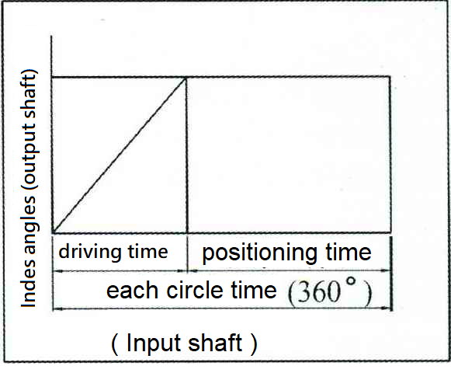
A、Index table (direct drive)
1. Number of index: S＝________
2. Driving angles θh＝________
3. Running time per circle＝index time+positioning time
__________second＝_______second＋______second
4. Input shaft speed＝________RPM
5. Cam curve＝□MS(standard) □MT □MCV
6. Disc material：□Steel □Aluminum □other________
O/D＝________mm Thickness t＝________mm
7. Workpiece weight：________Kg/each
8. Fixture weight：________Kg/each, Fixture pitch circle diameter (P.C.D)＝________mm
9. Supporter of under Disc.：□Yes □Non
Friction radius R1＝________ Coefficient of friction u＝________
10. Force of load when indexing：□Yes □Non
Force＝________kgf, Force radius R2＝________mm


